Year 12 Examination, 2019

Question/Answer Booklet

MATHEMATICS SPECIALIST

Section One: Calculator-free

Student Name/Number: ______________________________________________

Teacher Name: ______________________________________________

Time allowed for this section
Reading time before commencing work: five minutes
Working time for this section: fifty minutes

Materials required/recommended for this section
To be provided by the supervisor: This Question/Answer Booklet
Formula Sheet

To be provided by the candidate:
Standard items: pens (blue/black preferred), pencils (including coloured), sharpener,
correction fluid/tape, eraser, ruler, highlighters
Special items: nil

Important note to candidates
No other items may be taken into the examination room. It is your responsibility to ensure that you do not have any unauthorised notes or other items of a non-personal nature in the examination room. If you have any unauthorised material with you, hand it to the supervisor before reading any further.

Structure of this paper

Section | Number of questions available | Number of questions to be answered | Working time (minutes) | Marks available | Percentage of exam
Section One: Calculator-free | 8 | 8 | 50 | 50 | 35
Section Two: Calculator-assumed | 10 | 10 | 100 | 100 | 65
 |  |  |  |  | 100

Instructions to candidates

- The rules for the conduct of School exams are detailed in the _______________________________________School/College assessment policy. Sitting this examination implies that you agree to abide by these rules.

- Write your answers in this Question/Answer booklet preferably using a blue/black pen. Do not use erasable or gel pens.

- You must be careful to confine your answer to the specific question asked and to follow any instructions that are specified to a particular question.

- Show all your working clearly. Your working should be in sufficient detail to allow your answers to be checked readily and for marks to be awarded for reasoning. Incorrect answers given without supporting reasoning cannot be allocated any marks. For any question or part question worth more than two marks, valid working or justification is required to receive full marks. If you repeat any question, ensure that you cancel the answer you do not wish to have marked.

- It is recommended that you do not use pencil, except in diagrams.

- Supplementary pages for planning/continuing your answers to questions are provided at the end of this Question/Answer booklet. If you use these pages to continue an answer, indicate at the original answer where the answer is continued, i.e. give the page number.

- The Formula sheet is not to be handed in with your Question/Answer booklet.

Section One: Calculator-free 35% (50 Marks)
This section has eight questions. Answer all questions. Write your answers in the spaces provided.

Supplementary pages for planning/continuing your answers to questions are provided at the end of this Question/Answer booklet. If you use these pages to continue an answer, indicate at the original answer where the answer is continued, i.e. give the page number.

Working time: 50 minutes.

Question 1 (4 marks)

The complex number .

(a) Show that is purely imaginary. (3 marks)

(b) Determine the least positive number such that is real. (1 mark)

Question 2 (10 marks)

Consider the system of equations
in which and are constants.

(a) Write this system in augmented matrix form. (1 mark)

(b) Reduce this augmented matrix to echelon form. (3 marks)

(c) Hence deduce the value(s) of and for which the system of equations possesses
(3 marks)

- a unique solution

- no solutions

- infinitely many solutions

(d) Determine the general solution of the system of equations when it admits an infinity of solutions. (3 marks)

Question 3 (5 marks)

Suppose that the linear function $f\left(x\right)=ax+b$ is its own inverse.

Determine all possible values of the constants $a$ and $b$.

Question 4 (4 marks)

If is any non-zero complex number, prove that
.

Question 5 (6 marks)

Suppose that $f\left(x\right)=\sqrt{9-\left|5-2x\right|}$.

(a) For which real numbers $x$ is $f(x)$ defined? (3 marks)

(b) Sketch on the axes below the graph of $y=f(x)$. (3 marks)

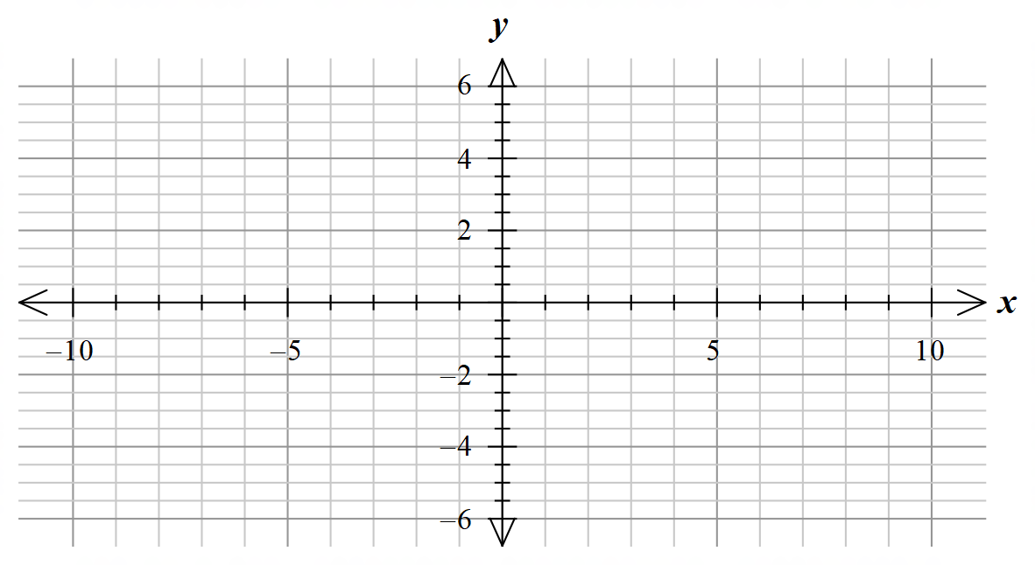

Question 6 (9 marks)

Suppose that Q is the plane defined by the equation $4x-3y+6z=12$.

(a) Sketch the triangle whose vertices are the and intercepts of the plane. (2 marks)

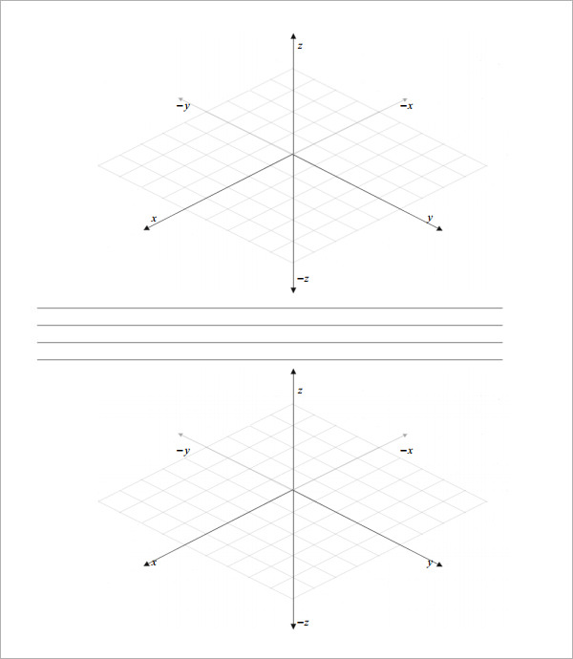

(b) Show that the point P= lies on Q. (1 mark)

(c) Show that the vector vijk is perpendicular to Q. (2 marks)

(d) Write down the Cartesian equation of the plane R that is parallel to Q and which contains the point . (2 marks)

(e) Determine a vector w that is perpendicular to both OP and v. (2 marks)

Question 7 (6 marks)

Determine the five roots of the equation
giving the answers in polar form with arguments lying in the range .

Question 8 (6 marks)

The graph of $y=f(x)$ is shown below.

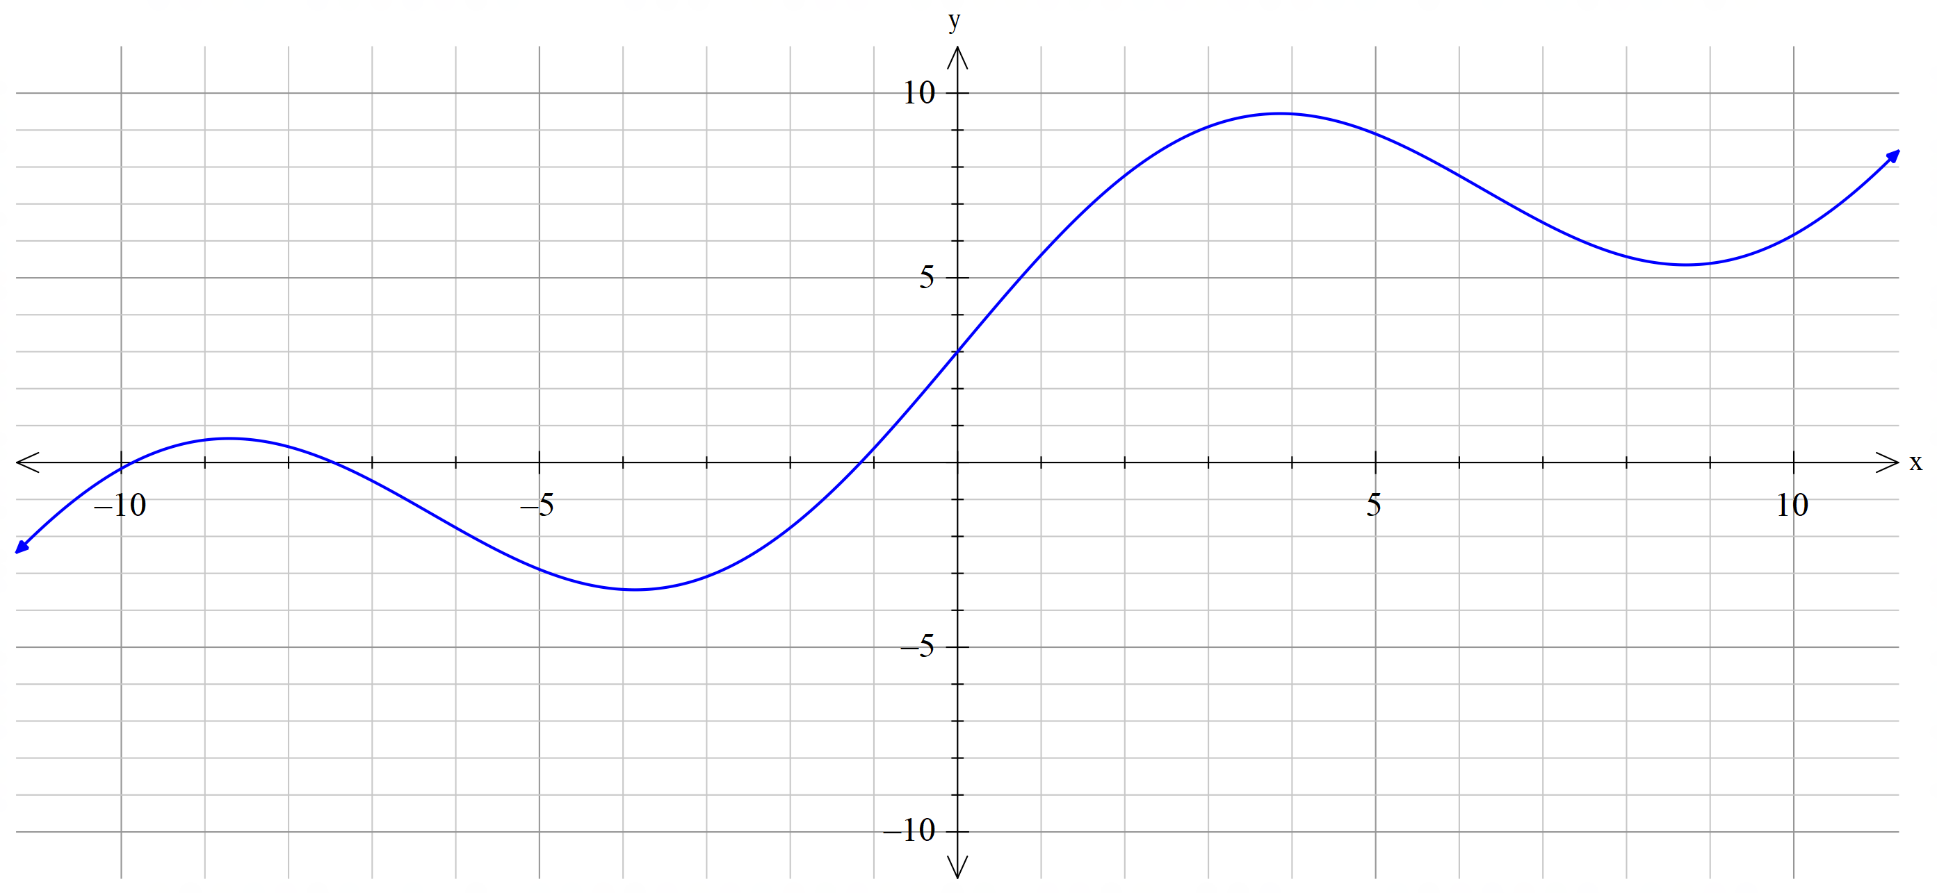
Sketch on the same axes the graphs of

(a) $y=f(x-3)$ (2 marks)

(b) $y=f\left(x\right)-3$ (2 marks)

(c) $y=f(\left|x\right|)$ (2 marks)

Make sure you distinguish clearly the three graphs.

Additional working space
Question number: __________________

Additional working space
Question number: __________________

Acknowledgements

© MAWA, 2019

This examination is Copyright but may be freely used within the school that purchases this licence.
- The items that are contained in this examination are to be used solely in the school for which they are purchased.
- They are not to be shared in any manner with a school which has not purchased their own licence.
- The items and the solutions/marking keys are to be kept confidentially and not copied or made available to anyone who is not a teacher at the school. Teachers may give feedback to students in the form of showing them how the work is marked but students are not to retain a copy of the paper or the marking guide until the agreed release date stipulated in the purchasing agreement/licence.
Published by The Mathematical Association of WA
12 Cobbler Place, MIRRABOOKA 6164.

